Read Me

Log In

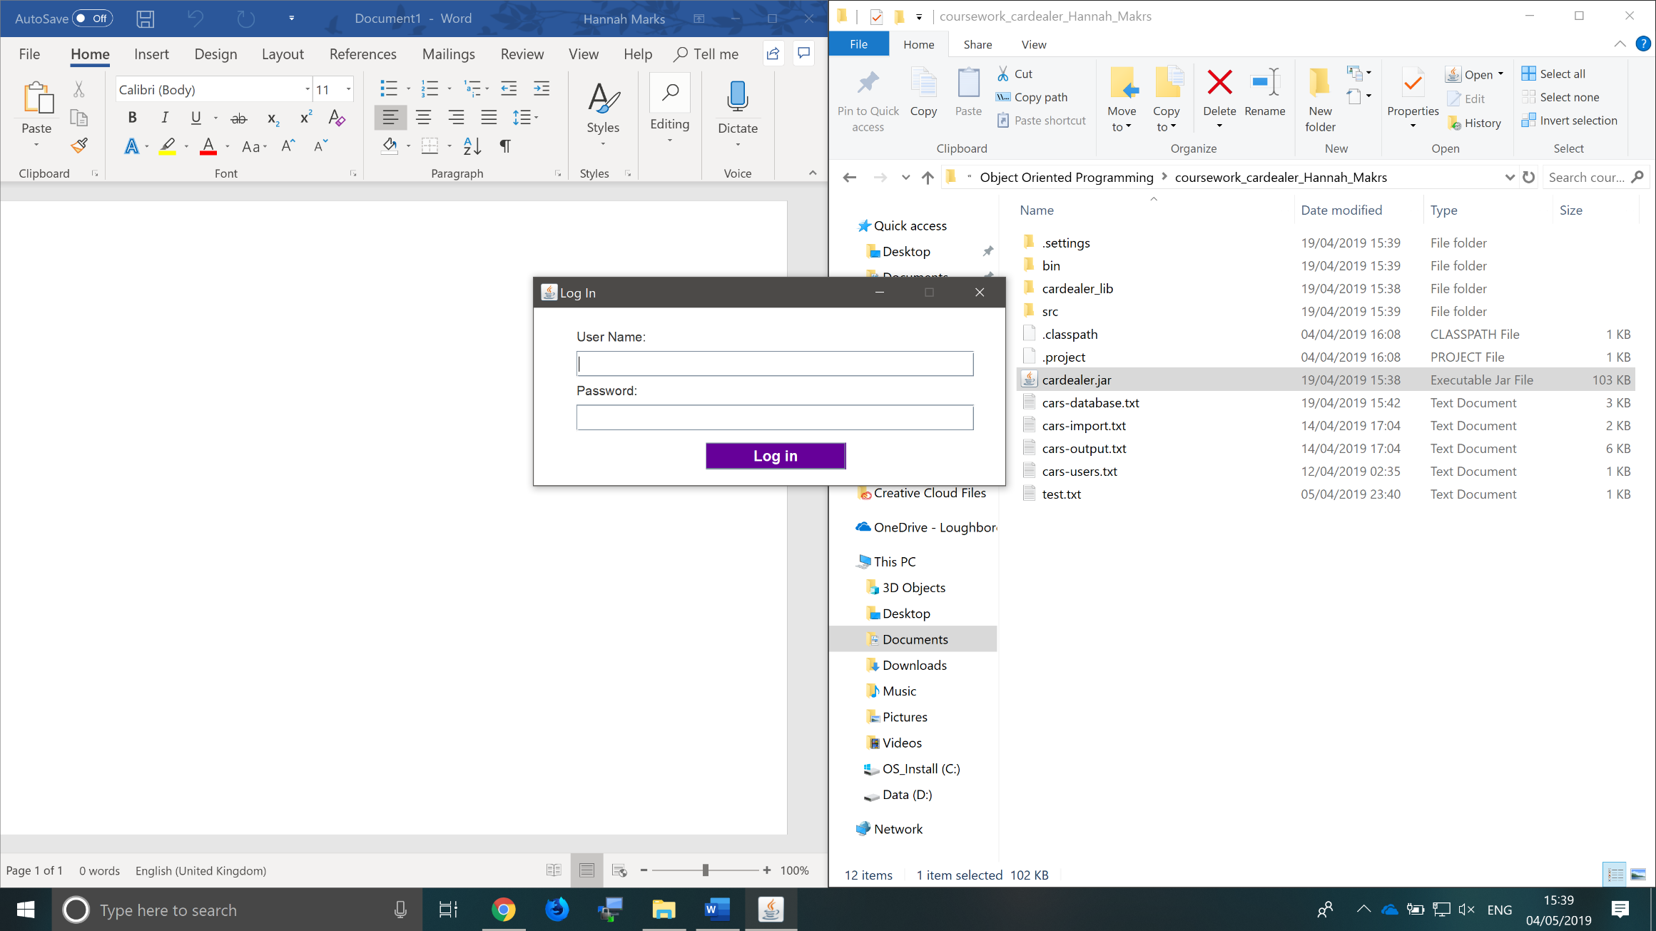On start-up you will see the log in window. To log into the program simply input your username and password into the relevant fields and press the “Log In” button. The credentials you have entered will then be checked against the user data file and you will be given access to the system accordingly (or not if you have entered any incorrect credentials).

Main Menu

Depending on your account type you will then see one of three different screens: the admin menu, the staff menu or the search page (this is the only page that customer users have access to). Clicking any of the buttons on the menu will navigate you to the relevant page.

Staff

Admin

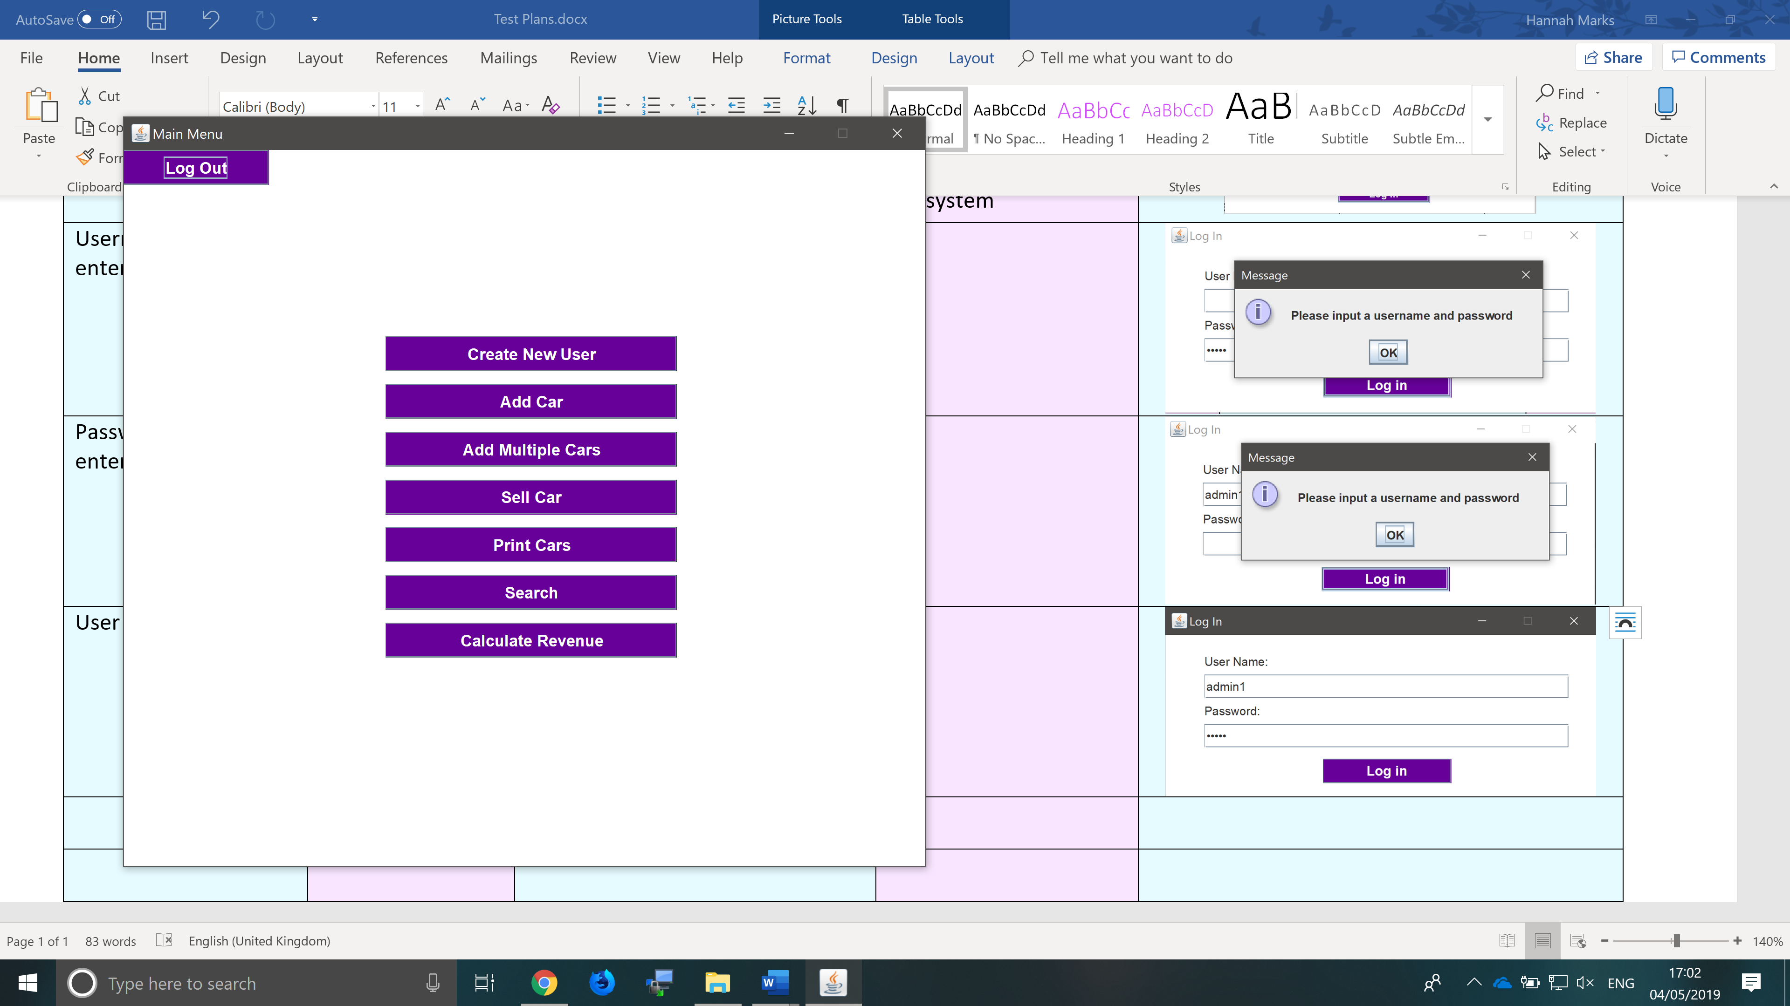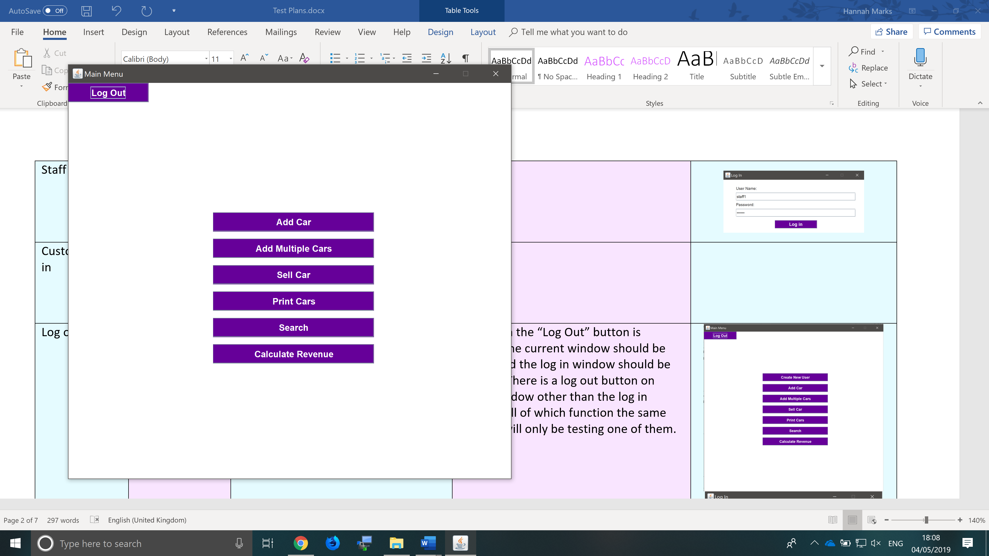

Search

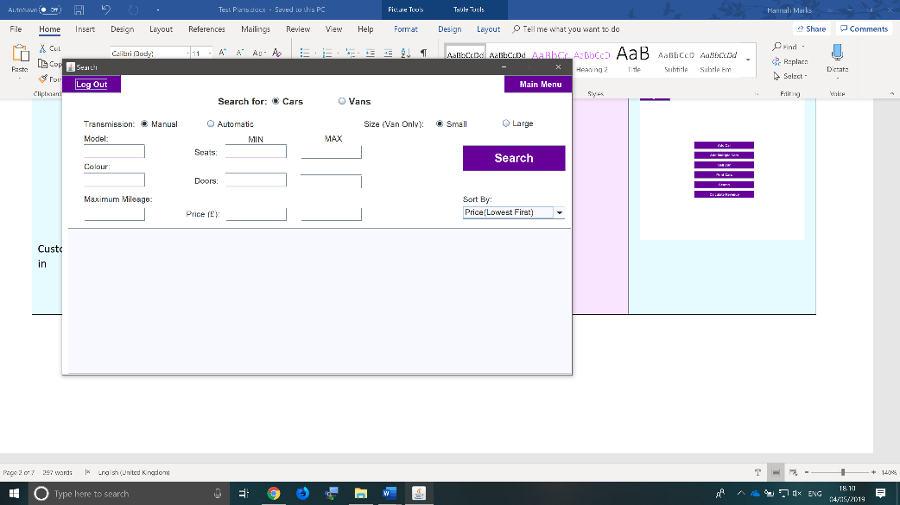In the search window you can use the filters to search the database, the results will be displayed in the pale blue box at the bottom of the window. This function searches the unsold/available cars only, if admin or staff users wish to see any of the details for any sold cars then they will need to use the print cars function. Customer type users will not be able to see the accident history of any of the cars. When using the sort function you must press the search button again to apply it. There is only a small amount of error checking as if the user enters anything incorrectly then there will simply not be any results.

The remaining features are for admin and staff users only.

Add Car

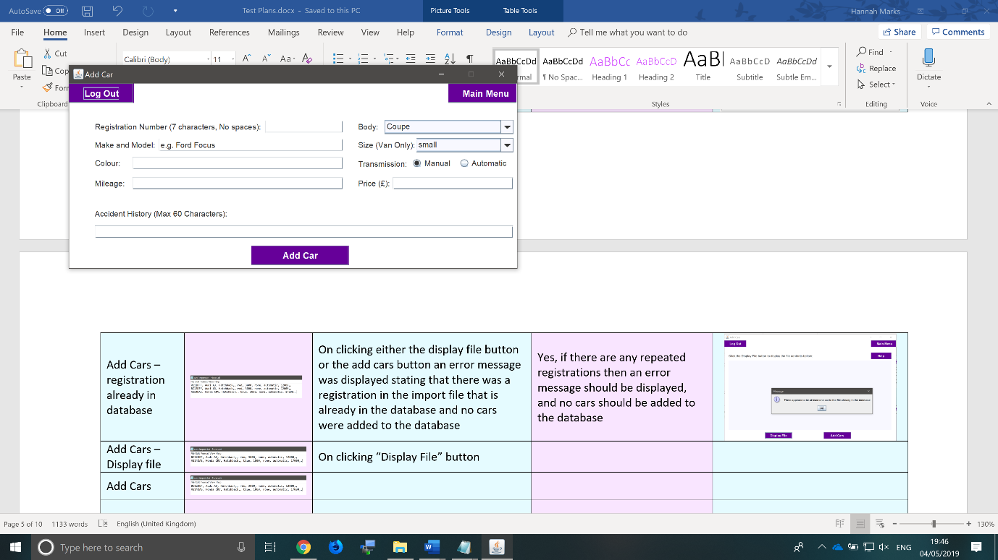The Add Car window is used to add a single car to the database (if you wish to add multiple cars at once please refer to the Add Cars function). Users must input all fields if any are left blank or are not acceptable inputs then an error message will be displayed. Commas (,) cannot be used in any of the input fields as this would cause errors in the database file. The mileage and price must only contain numbers. The size field is only relevant when “Van” is selected in the body type. If the registration number input already exists in the database then an error message will be displayed.

Add Cars

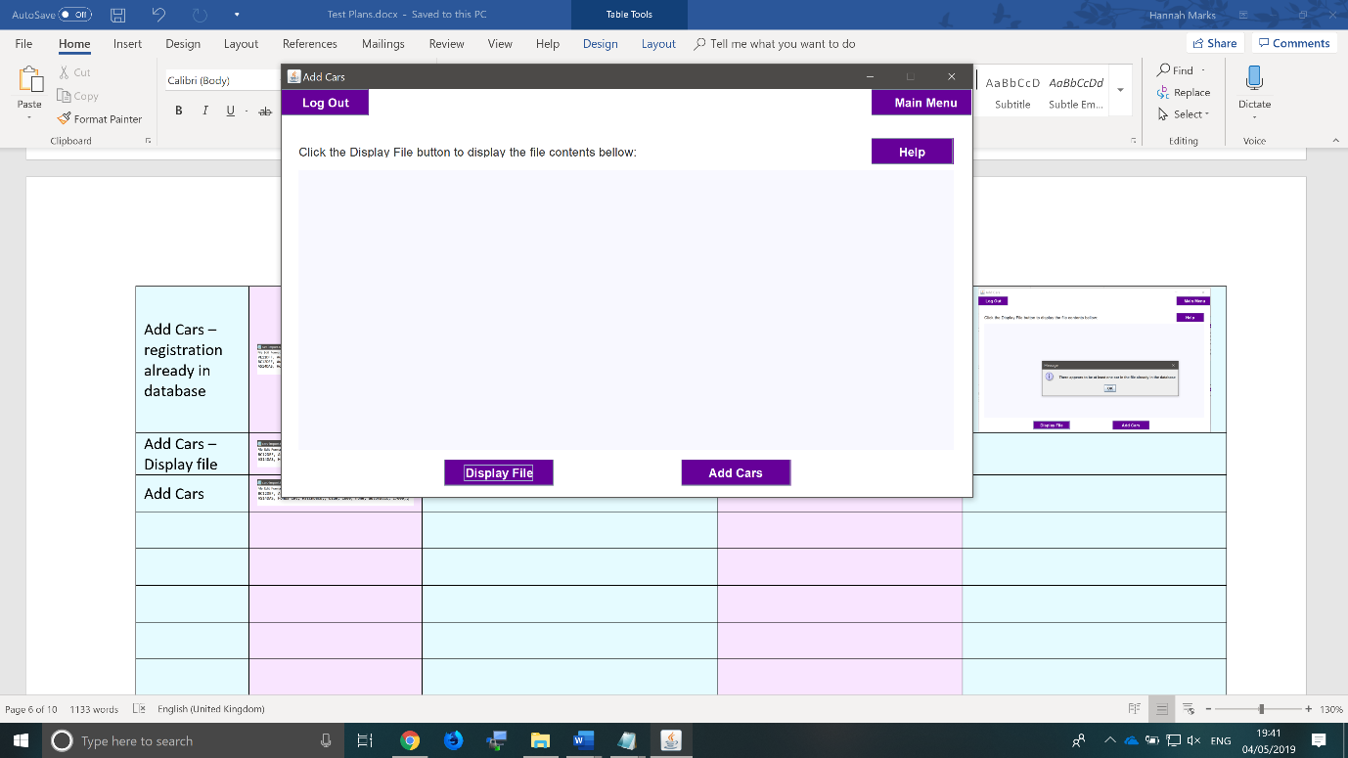The Add Cars function is used to add multiple cars to the database at once. The import file can be found in the program directory (full file name: cars-import.txt). To use this function simply alter the import file to contain the database entries for the cars you wish to add. If needed there is a “Help” button on the Add Cars window which contains all the information on how to properly format the car entries, what the acceptable inputs are for each field and how the arrival and sell dates are handled. If there is an error in the import file, then a message will be displayed. In addition, if the file contains any repeated registration numbers or any registrations that are already in the database then you will be informed. It is recommended that you click the “Display File” button before clicking “Add Cars” as this will give you a chance to review the import file and check for any errors yourself.

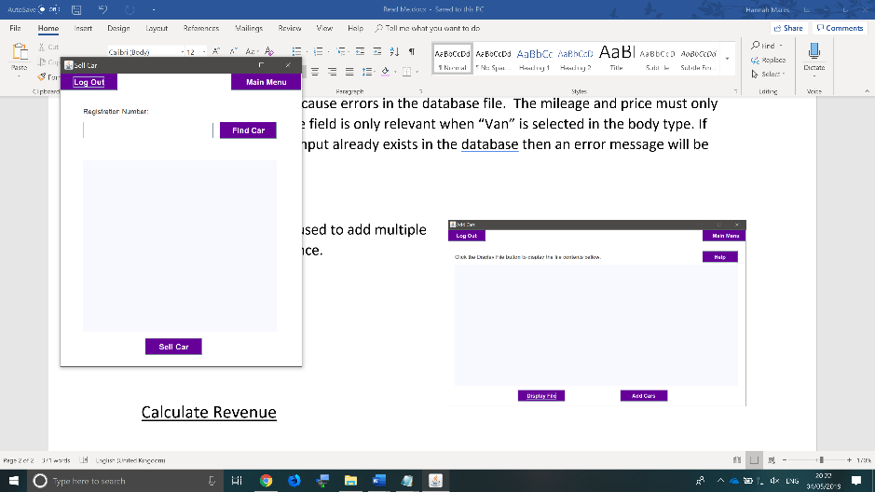Sell Car

The Sell Car function is used to sell a single car (it will change the car’s status to sold in the database). You are not able to sell more than 1 car at once. To use the function simply input the registration numberof the car you wish to sell into the input field and press the “Sell Car” button. It is reccommended that you click the “Find Car” button prior to sell car as this will display the information for that car in the pale blue text area, giving you a chance to confirm that you are selling the correct car. If there is an input error then the appropriate message will be displayed and the database will not be altered.

Print Cars

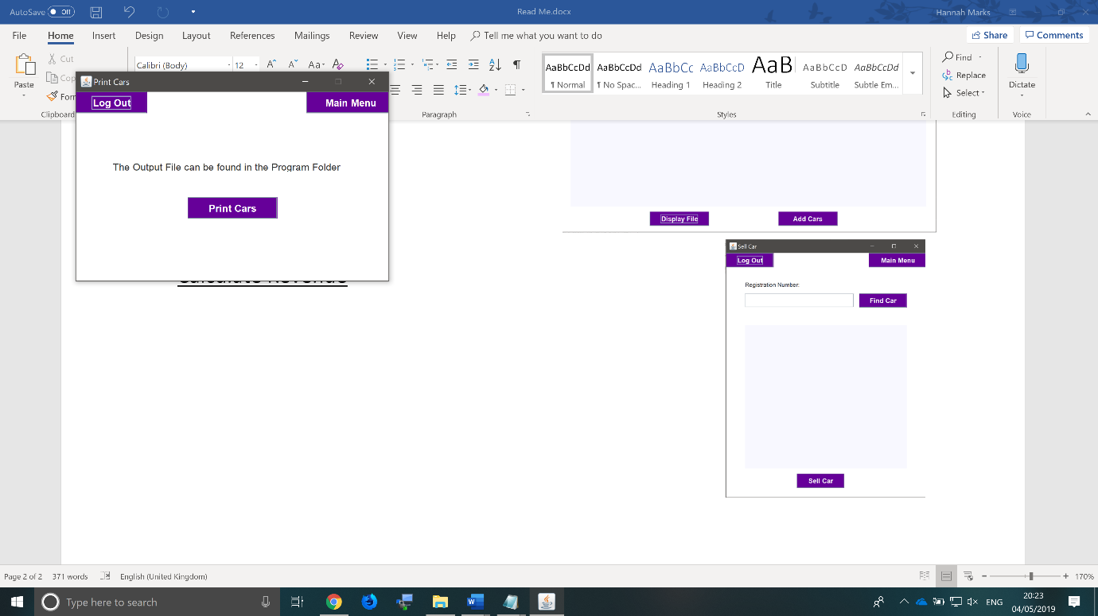The Print Cars function outputs a file of all the cars in the database sorted into sold and unsold cars. The output file can be found in the program directory and is called “cars-output.txt”. To use this function simply open the window and press the “Print Cars” button.

Calculate Revenue

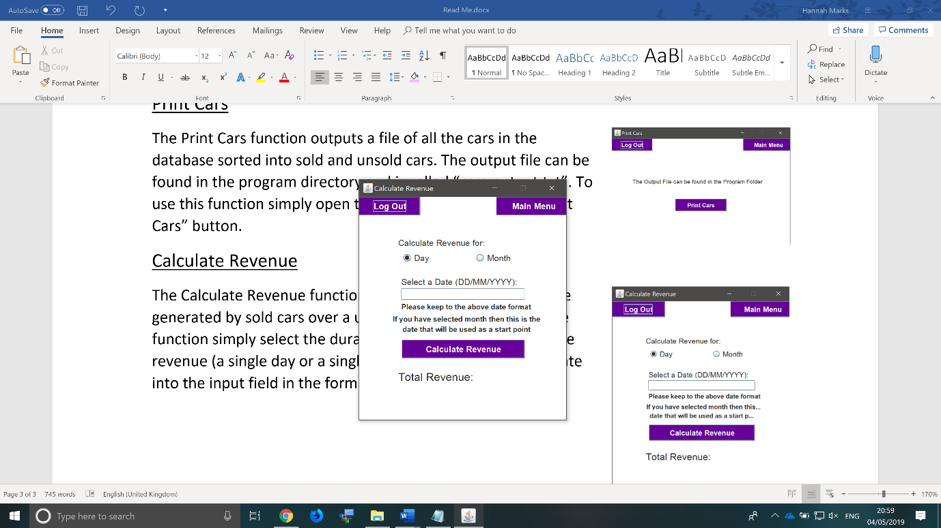The Calculate Revenue function is used to display the revenue generated by sold cars over a user set time period. To use the function simply select the duration over which to calculate the revenue (a single day or a single month), then input a start date into the input field in the format specified in the label and click the “Calculate Revenue” button. This will display the revenue in the “Total Revenue” label below. If there are any input errors, then an error message will be displayed.

Create New User (Admins only)

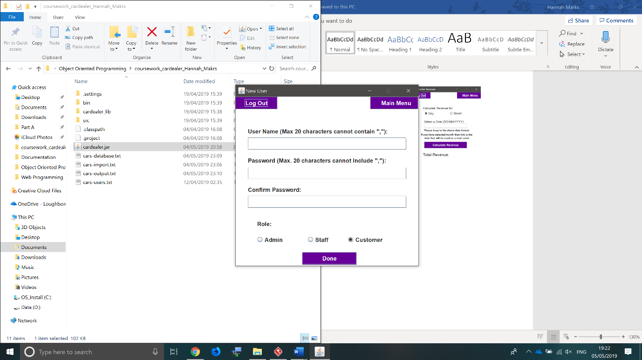The Create New User function is only available for admins and is used to create new user log-in details. To use the function you must enter a unique username and password (neither of which can exceed 20 characters in length) and you must then re enter the password into the confirm password input. The username and password are both case sensitive and cannot contain any commas (,). If the passwords do not match then you will receive an error message. You must also select the type of account to create (admin, staff or customer) by selecting one of the radio buttons at the bottom of the window. Once you are done click the “Done” button to submit and the user details file will be updated.